Printing ALeP Packs using MakePlayingCards

A Long-extended Party (ALeP) provides two ways to print out the packs as they are released using MakePlayingCards (MPC): using links to existing MPC projects, and using 7z files. We recommend using links to MPC projects if you want to print a pack without any modifications, but it is possible to customize the pack manually using the provided 7z files, which you can use to create your own MPC project link to share with others.

All MPC project links and 7z files can be found at <https://www.alongextendedparty.com>.

# Signing In

1. Open <http://www.makeplayingcards.com>.
2. Select **Sign In**.

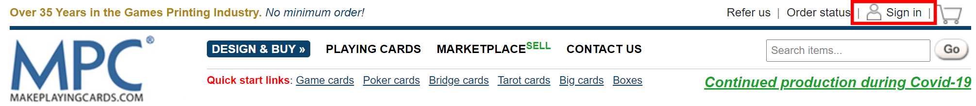

1. Enter the email address and password associated with your MakePlayingCards account.
   * If you don’t have an account, you can choose to either **Register**, **Login with Facebook**, or **Sign in with Google**, and follow the on screen prompts to set up an account.
2. Select **Login**.

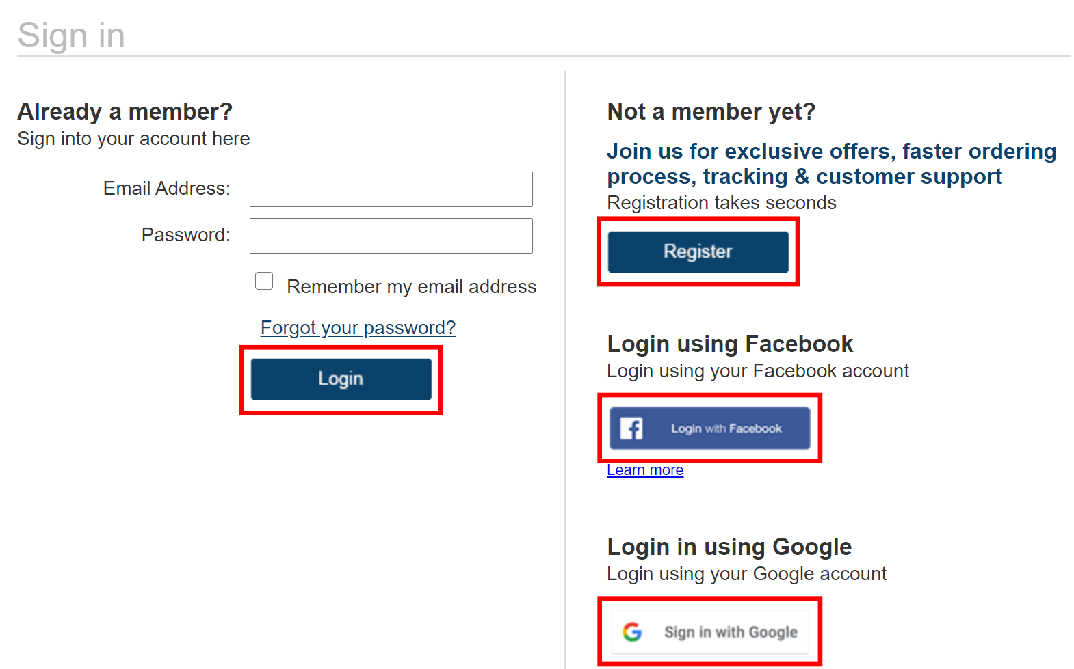

# Using Links to MakePlayingCards Projects

There is a bug on MakePlayingCards web-site that makes impossible ordering two decks within the same browser session. If you want to order several decks you need either to restart the browser after adding each new deck or to open a private window, add a deck, close the private window, open a new private window, add a new deck, etc. You can’t add two decks in parallel, even in different private windows.

1. Sign in to your MakePlayingCards account (see Signing In for details).
2. Open the desired ALeP project link. You should see a screen with the front images for the deck.
3. Don’t change anything on the screen and click **Next Step**.

1. Don't change anything, just click **Next Step** on each screen until you reach **Preview & Add to Cart**.

1. Scroll down to the bottom of the page, select the **Yes, I confirm that all the images…** checkbox and click **Add to Cart**.

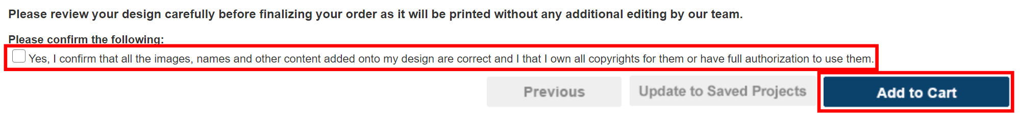

1. Enter the desired number of packs in the **Quantity** field and select **Update**.

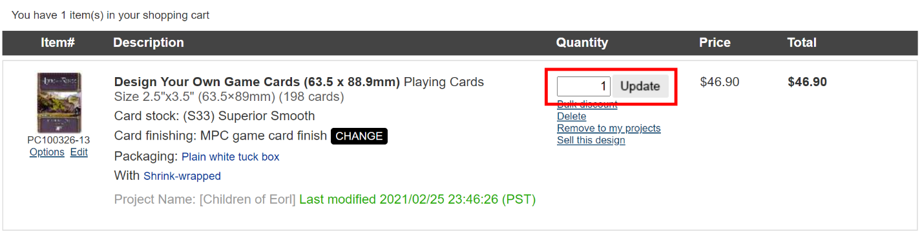

1. Select **CHANGE** next to the printing options. (Optional)
   * This is only necessary if you would like to change the card stock option of the project. If you’re satisfied with the current card stock option, skip to step 9.
2. Choose one of the following options in the **Card stock** dropdown:
   * **(S30) Standard Smooth:** slightly cheaper, moderate quality
   * **(S33) Superior Smooth:** highly recommended, slightly more expensive, higher quality
3. Select **Update**. Alternatively, you can select **Close** without changing any of the printing options.

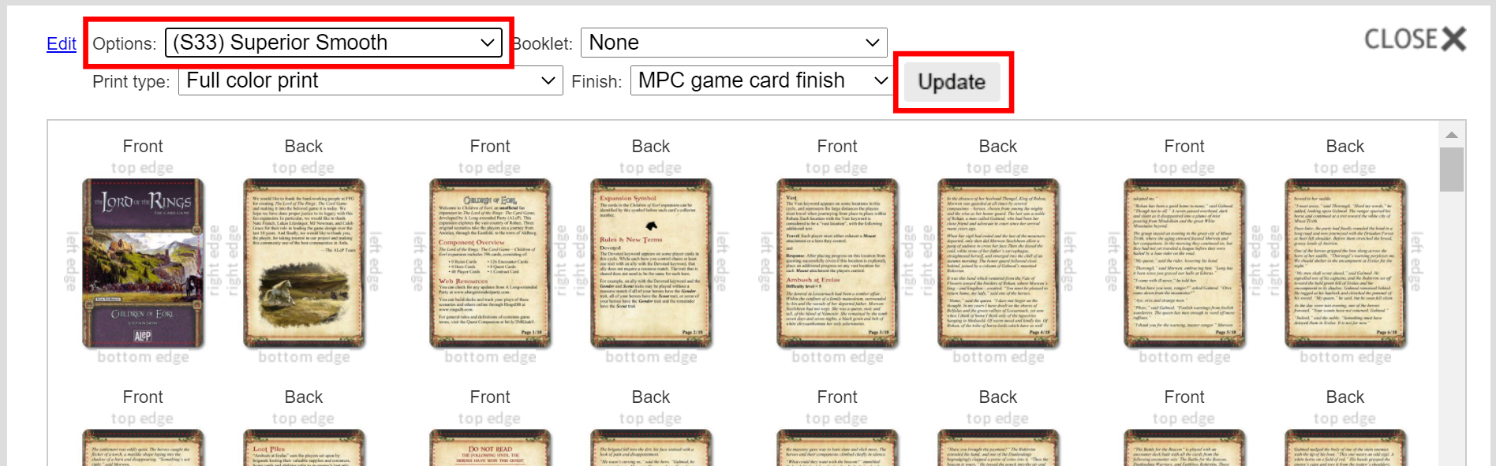

1. Select the blue packaging option next to “Packaging”. In the example below, the current packaging option is **Plain white tuck box**, but your project’s packaging option might be different. (Optional)
   * This is only necessary if you would like to change the **Packaging** and/or **Wrapping** of the project. If you’re satisfied with the current **Packaging** and **Wrapping** options, skip to step 12.

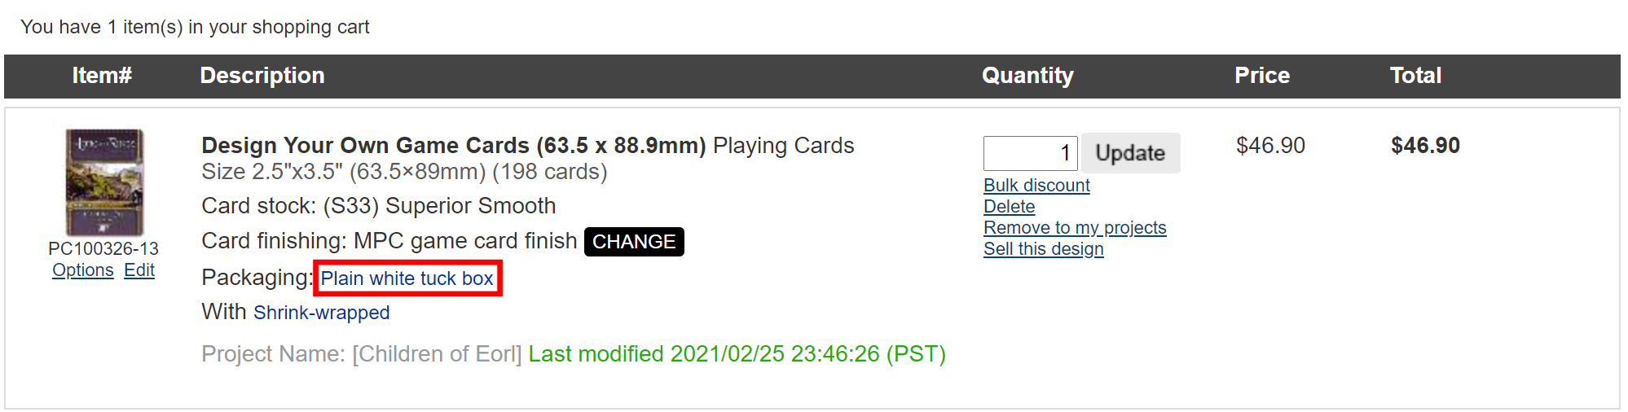

1. Change the **Packaging** and/or **Wrapping** options as needed.
   * Note that the **Wrapping** option is only present while certain **Packaging** options are selected, and that you are required to upload your own files for some of the **Packaging** options.

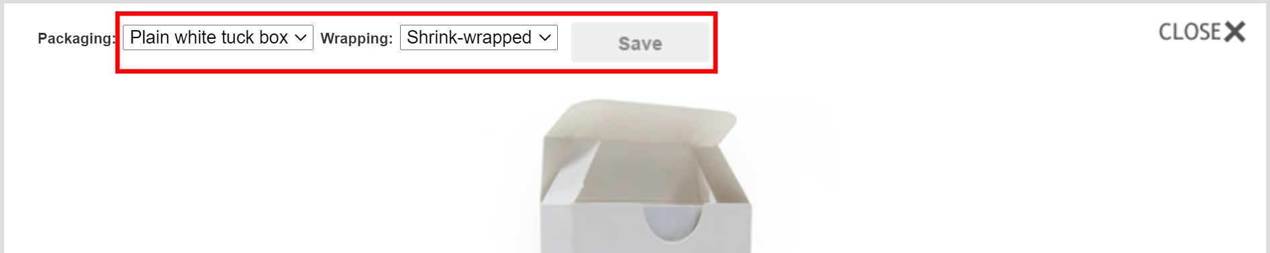

1. Select **Save**. Alternatively, you can select **Close** without changing the **Packaging** or **Wrapping** options.
2. Select **Go to Checkout**.

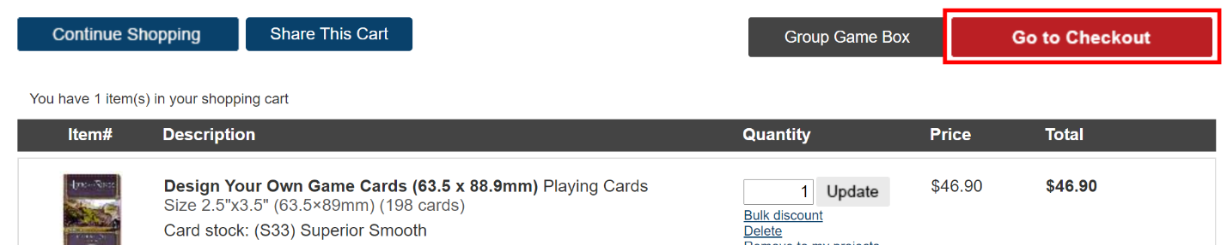

1. Select your payment method.
2. Fill out the following sections:
   * **Billing and Shipping Address**
   * **Shipping Method**
   * **Payment**
3. If you selected **Credit Card** as your payment method, enter your credit card information. Otherwise, skip to step 17.
4. Select **Submit Order**.

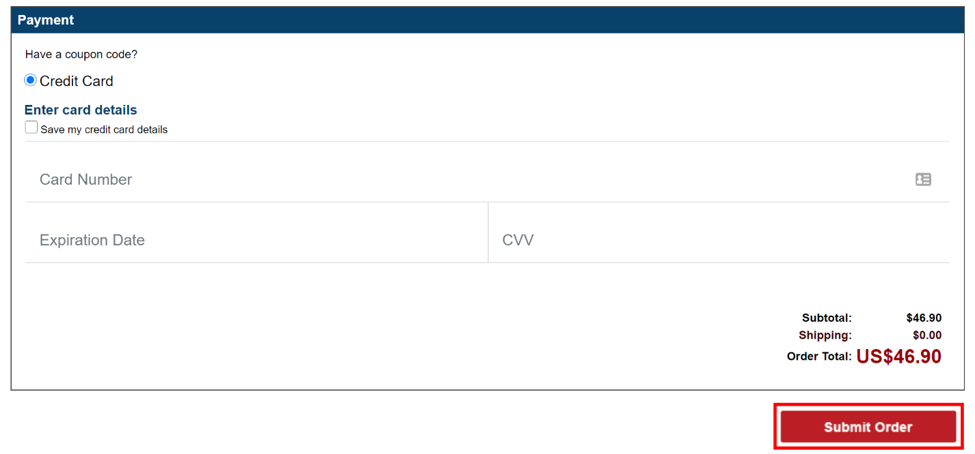

1. If you selected PayPal as your payment method, select **Continue**. If you selected **Credit Card** as your payment method, skip the rest of the steps in this section.
2. Follow the on screen prompts to enter your PayPal information to submit your order.

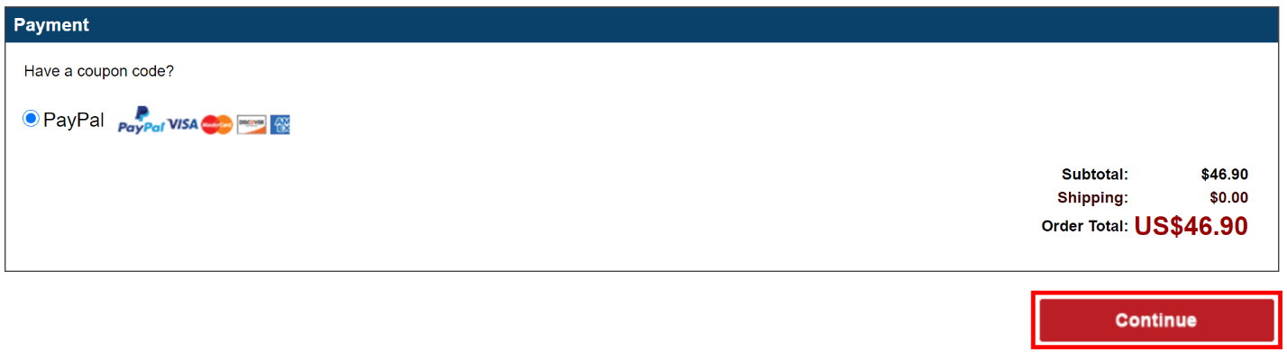

# Customizing the ALeP Pack

If you want to customize the ALeP pack, you can download the image files and modify the pack directly. For example, you may want to combine several packs together or add additional copies of player cards.

Note that in order to open an ALeP 7z archive, you will need to have a program installed on your computer that allows you to extract 7z files. If your computer does not have a program to extract 7z files, follow the steps provided in this link to install an open source freeware depending on your operating system (Windows, Mac, or Linux): <http://www.e7z.org/open-7z.htm>.

## Modify the MakePlayingCards Archive

1. Download the MakePlayingCards **7z** archive from the ALeP website.
   * **Make sure that the archive’s name starts with “MPC”**.
2. Extract the files from the archive to a folder on your computer.
   * The archive should contain two folders: **front** and **back**.
3. Modify the files in the **front** and **back** folders as needed.
   * **When you modify the number of cards in either the front or back folder, make sure that the other folder's images are also updated. The number of files in the front folder should equal the number of files in the back folder. For example, if you add a player card, ensure that you add both the front and back image for that player card.**
   * **When adding cards to your pack, ensure that all images are in RGB PNG format and are 3.74 in x 2.74 in.**

## Set Card Printing Options

1. Sign in to your MakePlayingCards account (see Signing In for details).
2. Open <https://www.makeplayingcards.com/design/custom-blank-card-traditional-size.html>.
3. Set the following options in the **Design Your Own Game Cards (63.5 x 88.9mm)** menu:
   * **Card stock**: select one of the following options:
     + **(S30) Standard Smooth:** slightly cheaper, moderate quality
     + **(S33) Superior Smooth:** highly recommended, slightly more expensive, higher quality
   * **Size of deck**: select the number of cards in your customized pack.
     + For the Children of Eorl deluxe expansion, it’s **Up to 198 cards**.
     + This value might vary based on how you customized the pack.
   * **Print type**: Full color print
   * **Finish**: MPC game card finish
   * **Packaging**: Any option
   * **Wrapping**: Any option
   * **Booklets**: None
4. Select **start your design**.

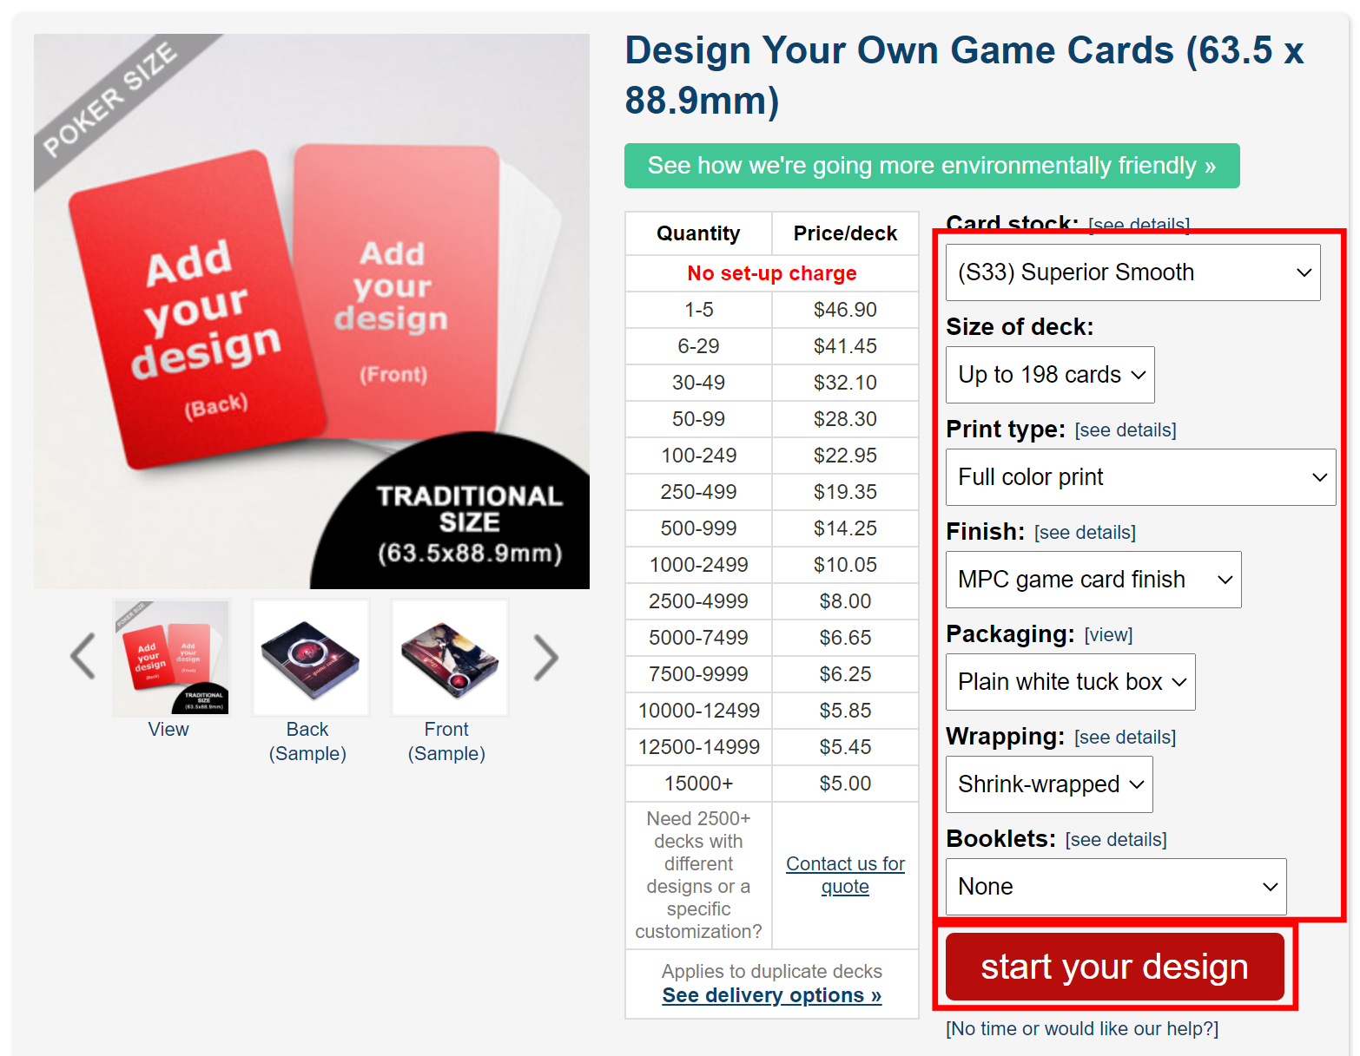

## Upload Front Images

1. Select **Different images**.

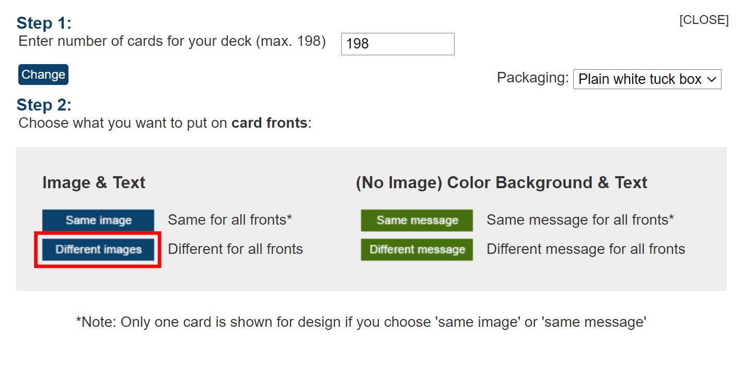

1. Select **Upload images**.

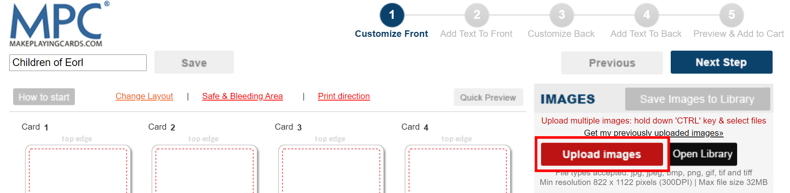

1. Navigate to your **front** folder (where you extracted the 7z archive in the Modify the MakePlayingCards Archive section).
2. Select allimage files in the **front** folder.
3. Select **Open**.
4. Wait until all images have been uploaded.
   * Note that this might take a while depending on your Internet connection speed.
5. Select **Help me autofill images!**

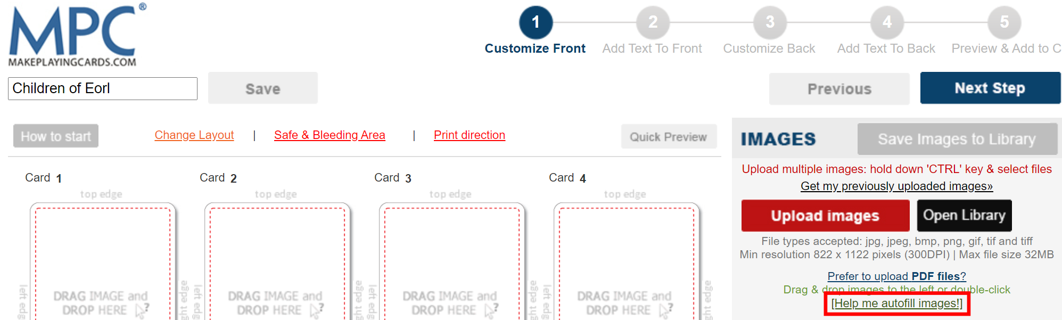

1. Wait until all images have been placed into the preview area on the left.
2. Select **Next Step**.

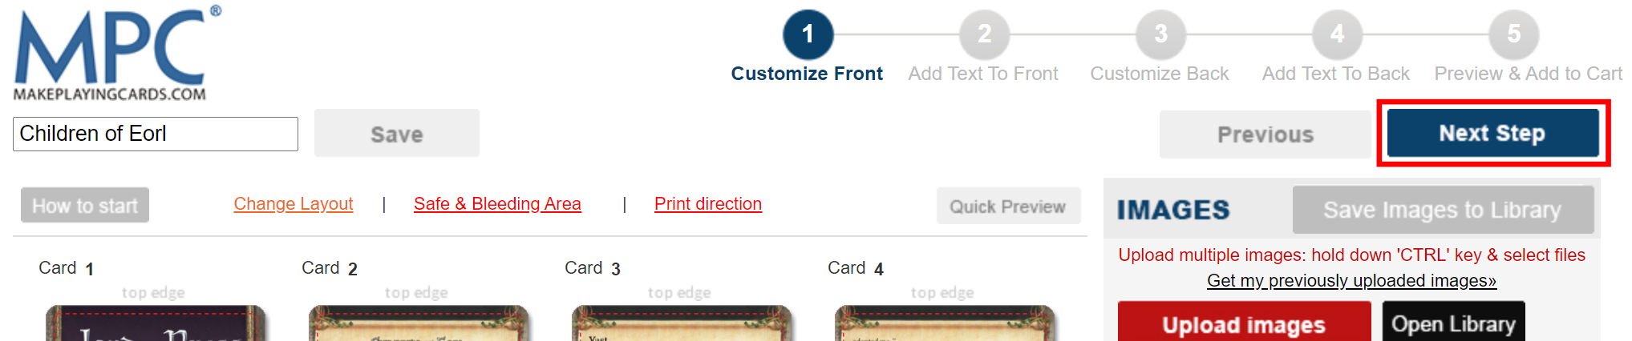

1. Select **Next Step**.

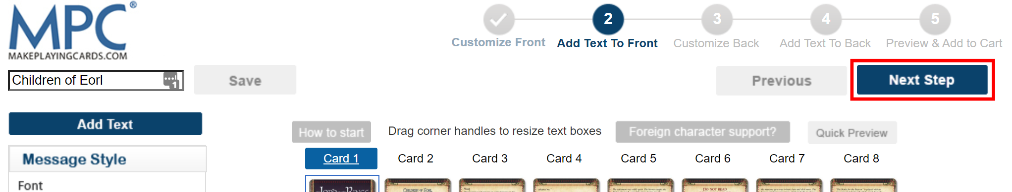

## Upload Back Images

1. Select **Different images**.

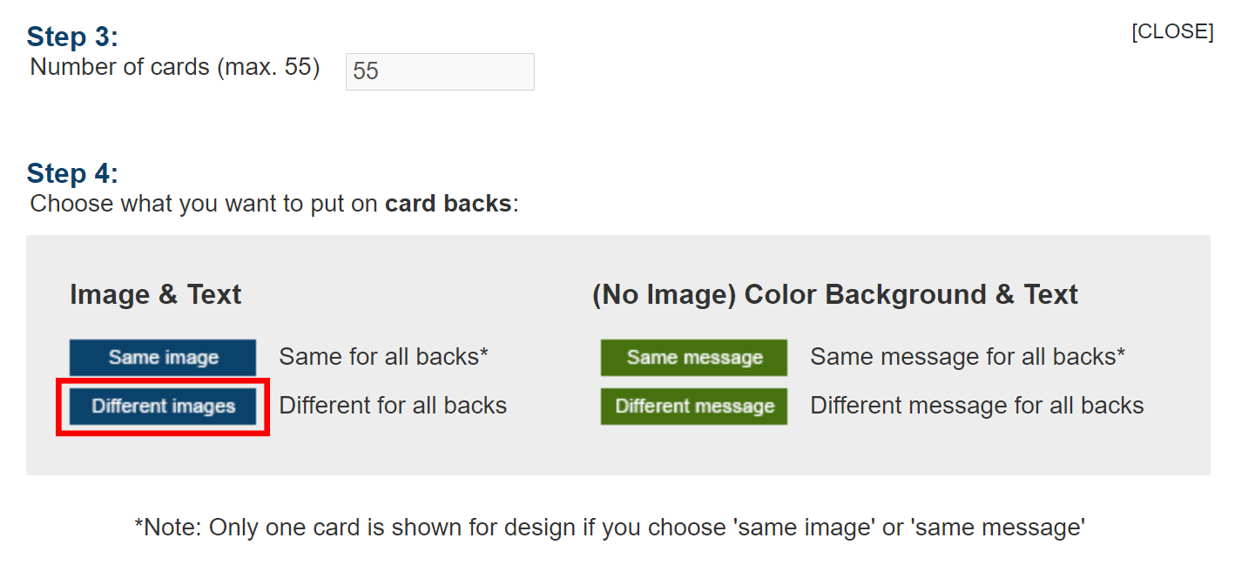

1. Select **Upload Images**.

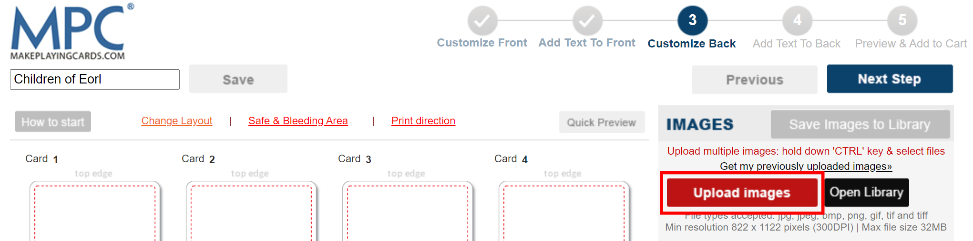

1. Navigate to your **back** folder (where you extracted the 7z archive in the Modify the MakePlayingCards Archive section).
2. Select allimage files in the **back** folder.
3. Select **Open**.
4. Wait until all images have been uploaded.
   * Note that this might take a while depending on your Internet connection speed.
5. Select **Help me autofill images!**

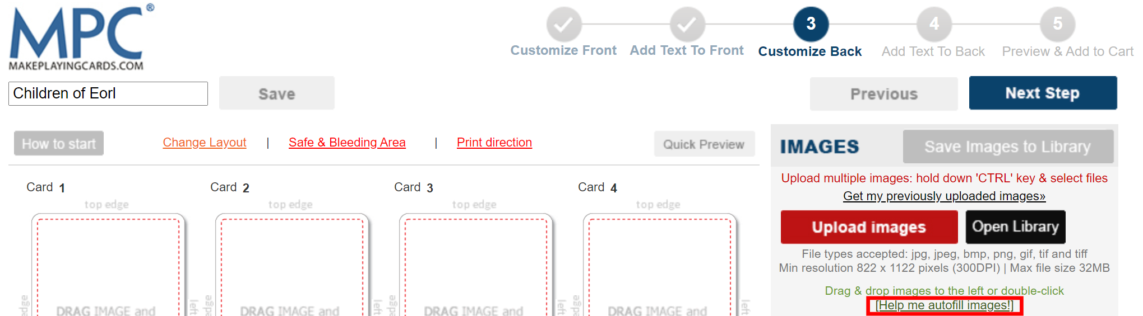

1. Wait until all images have been placed into the preview area on the left.
2. Select **Next Step**.

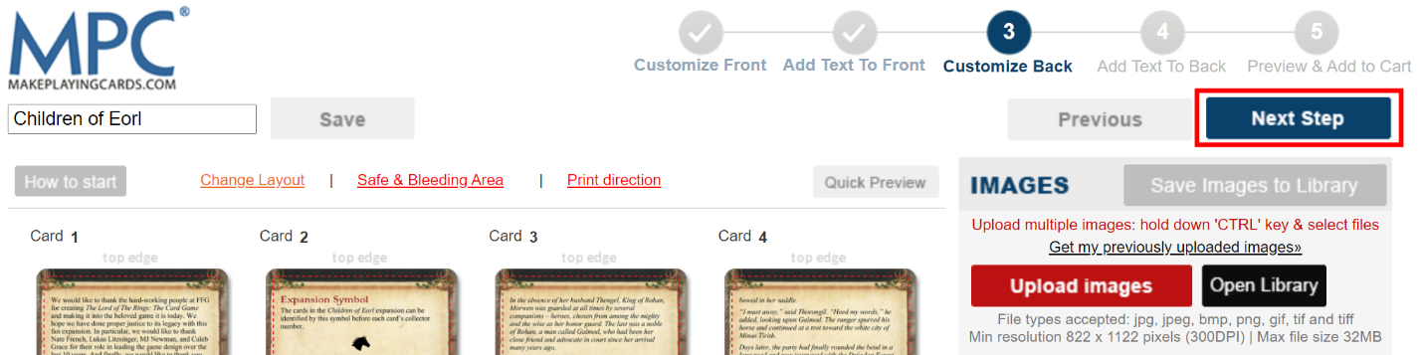

1. Enter a project name in the input field in the top left corner of the screen. (Optional)
   * This is only necessary if you would like to create a MakePlayingCards project link to share with others (see Creating a MakePlayingCards Project Link for details). If you do not want to save your deck as a saved project, skip to step 12.

**Note that when you are saving your deck as a MakePlayingCards project, do NOT include “Lord of the Rings,” “LOTR,” or any other mention of the Lord of the Rings franchise in the project name. Doing so might get your project flagged by MPC, resulting in them not printing your project.**

1. Select **Save**.
   * The text **Saving your design…** will appear and display **Saved Successfully** when it has finished saving your project. Note that this might take some time depending on the size of your project.

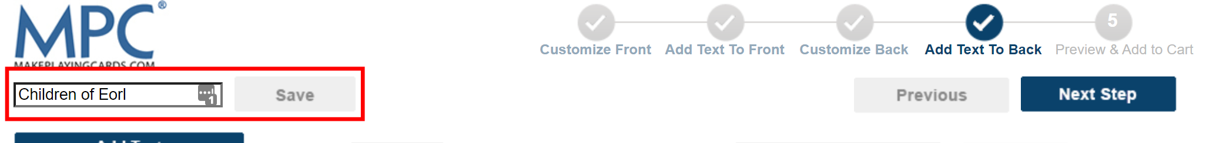

1. Select **Next Step**.

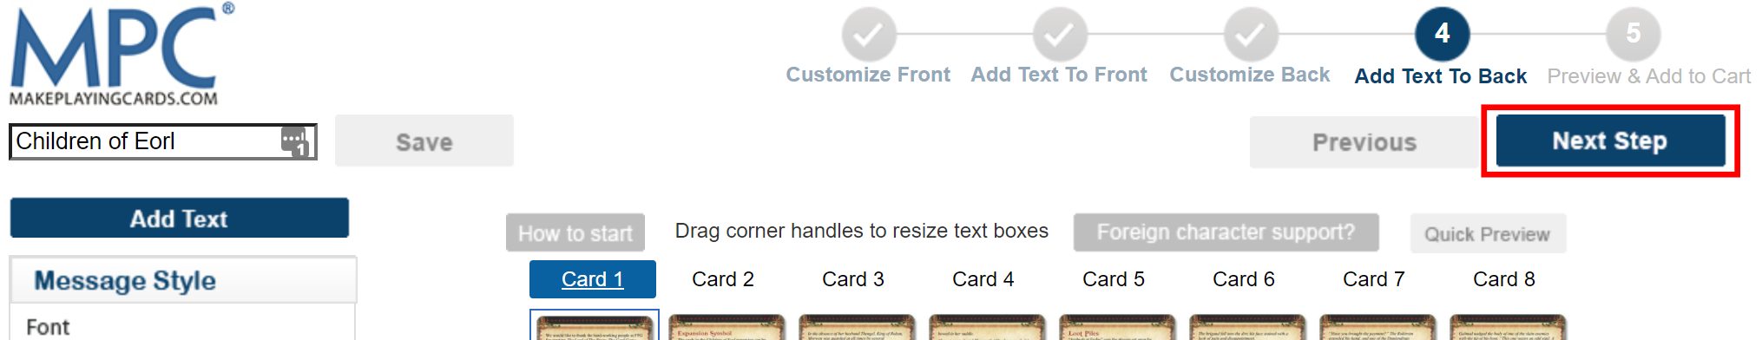

## Checkout and Complete Order

1. Review the front and back sides of all cards in the preview area.
2. Scroll down to the bottom of the page and select the **Yes, I confirm that all the images…** checkbox.
3. Select **Add to Cart**.



1. Select **Remove to my projects**. (Optional)
   * This is only necessary if you would like to create a MakePlayingCards project link to share with others (see Creating a MakePlayingCards Project Link for details). If you do not want to save your deck as a saved project, skip to step 8.
   * Note that you do not have to select this option if you have already saved your latest changes to your deck in steps 10 and 11 in the Upload Back Images section.
   * **Note that this is the last opportunity to save your deck as a project before placing your order. Once you place your order, you must use the** **Reordering Your Deck** **method to save your deck as a project.**

**Note that when you are saving your deck as a MakePlayingCards project, do NOT include “Lord of the Rings,” “LOTR,” or any other mention of the Lord of the Rings franchise in the project name. Doing so might get your project flagged by MPC, resulting in them not printing your project.**

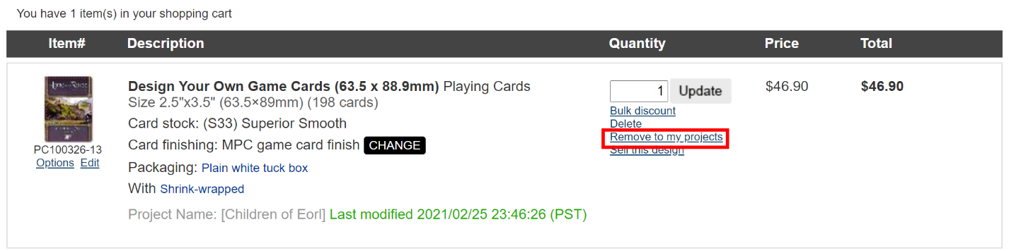

1. Select **OK** in the browser prompt to verify you want to remove your deck from your cart.
2. Find the deck under **My saved projects.**
3. Select **Add to cart** next to your pack.

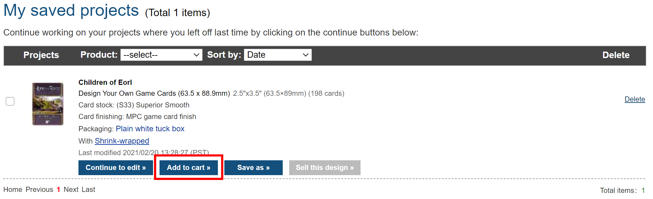

1. Enter the desired number of packs in the **Quantity** field and select **Update**.

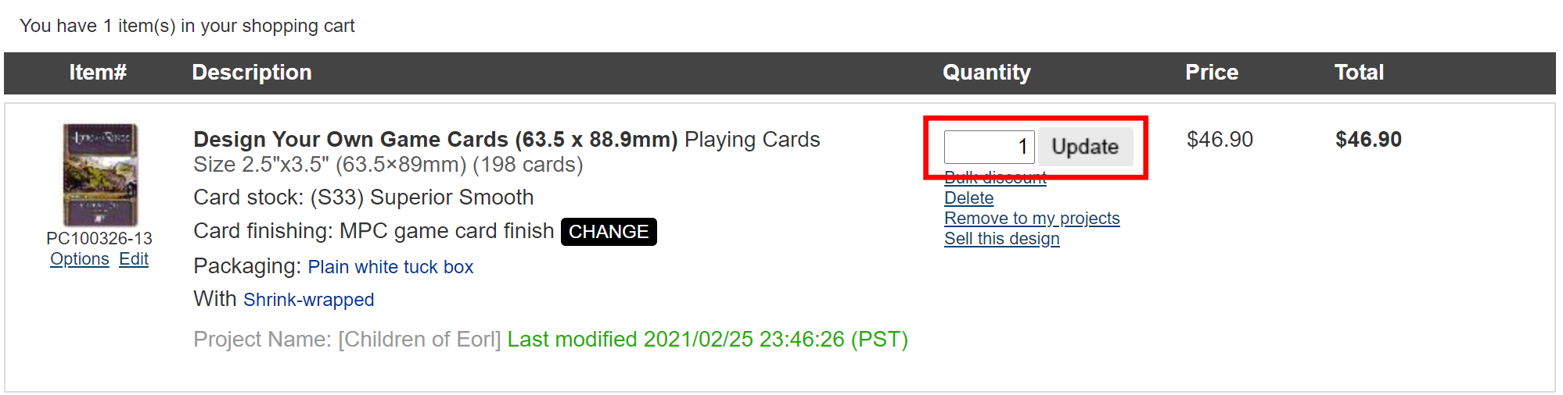

1. Select **Go to Checkout**.

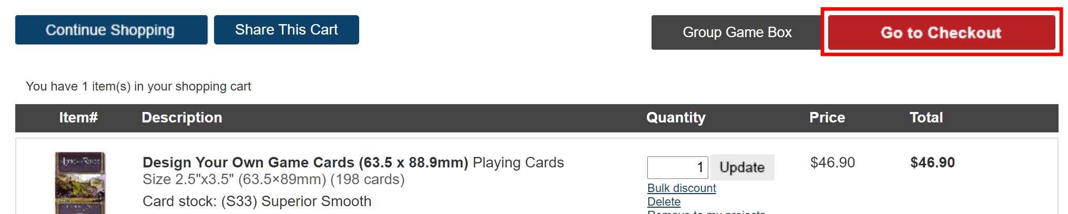

1. Select your payment method.
2. Fill out the following sections:
   * **Billing and Shipping Address**
   * **Shipping Method**
   * **Payment**
3. If you selected **Credit Card** as your payment method, enter your credit card information. Otherwise, skip to step 14.
4. Select **Submit Order**.

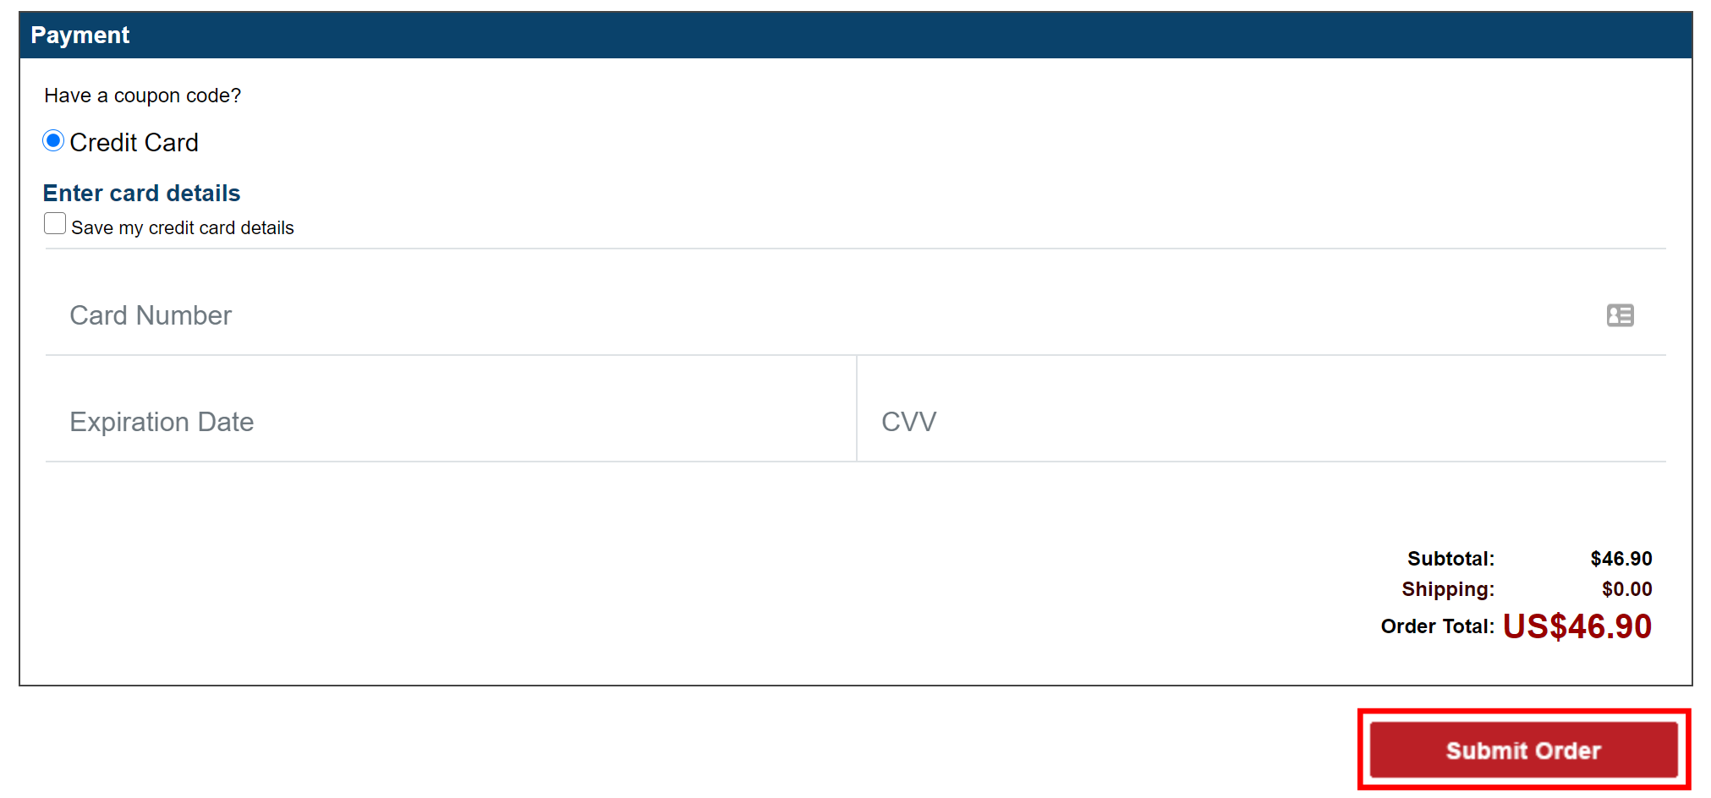

1. If you selected PayPal as your payment method, select **Continue**. If you selected **Credit Card** as your payment method, skip the rest of the steps in this section.
2. Follow the on screen prompts to enter your PayPal information to submit your order.

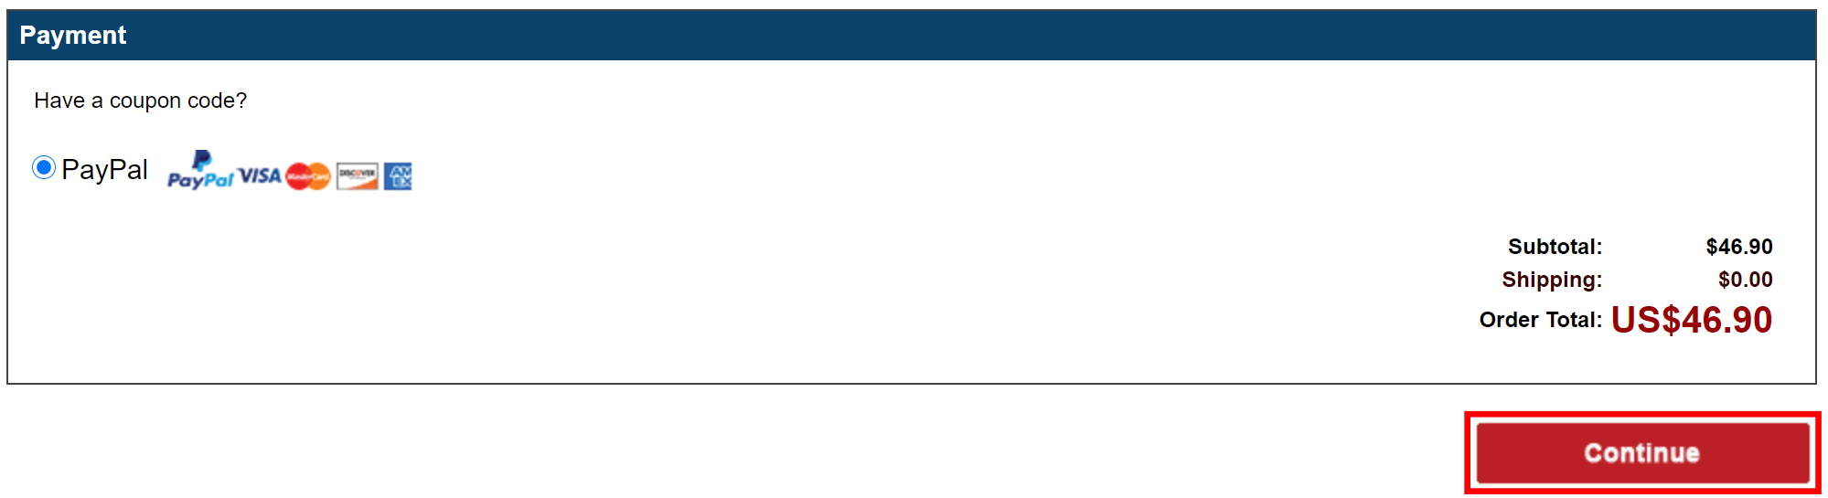

# Saving Your Deck as a MakePlayingCards Project

There are multiple ways to save your customized pack as a saved project, which you can edit at a later time and create a link to share with others (see Creating a MakePlayingCards Project Link for details). There are three methods of saving your pack:

1. Editing your deck
2. Removing the deck from your cart
3. Reordering your deck

**Note that when you are saving your deck as a MakePlayingCards project, do NOT include “Lord of the Rings,” “LOTR,” or any other mention of the Lord of the Rings franchise in the project name. Doing so might get your project flagged by MPC, resulting in them not printing your project.**

You can see a list of all of your saved projects by selecting **Saved projects**.

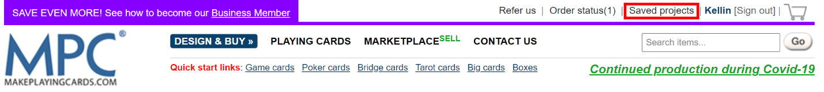

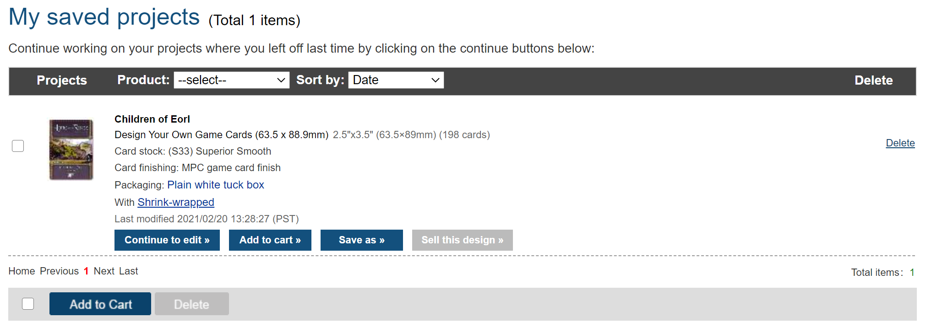

## Editing Your Deck

You can save your deck when you are finished editing your deck in the editor (see step 10 in Upload Back Images for details).

To save your deck in the editor:

1. Upload your front images to your deck (see Upload Front Images for details).
2. Upload your back images to your deck (see Upload Back Images for details).
3. Enter a project name in the input field in the top left corner of the screen.
4. Select **Save**.
   * The text **Saving your design…** with appear and display **Saved Successfully** when it has finished saving your project. Note that this might take some time depending on the size of your project.

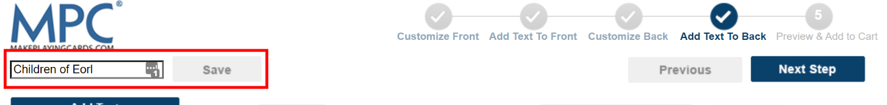

## Removing the Deck From Your Cart

Another way of saving your deck as a project is removing it from your cart before submitting your order (see Checkout and Complete Order for details).

To remove your deck from your cart:

1. Select the **Cart** icon.

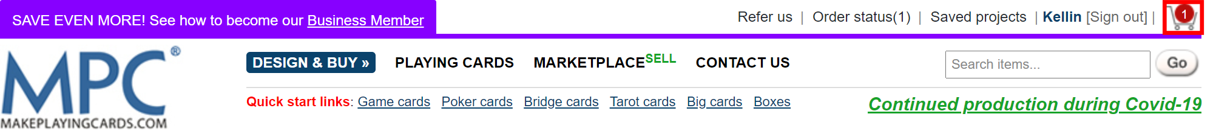

1. Locate the deck that you would like to save.
2. Select **Remove to my projects** in that deck’s listing.

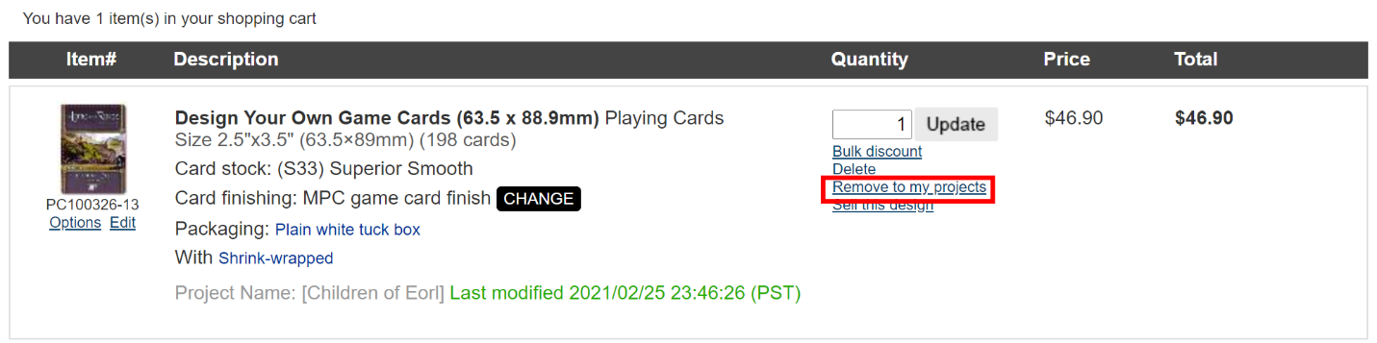

1. Select **OK** in the browser prompt to verify you want to remove your deck from your cart. You should be redirected to your **Saved projects** page where you will see all of your saved projects.

## Reordering Your Deck

The last way of saving your deck as a project is by reordering your deck. **Once you place an order, you no longer have the option to save it as a project except by reordering your deck**.

To reorder your deck:

1. Select **Order status**.

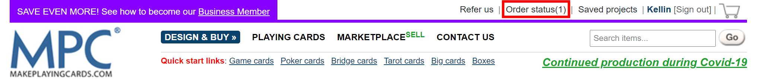

1. Find the order that included your deck.
2. Select **reorder**.

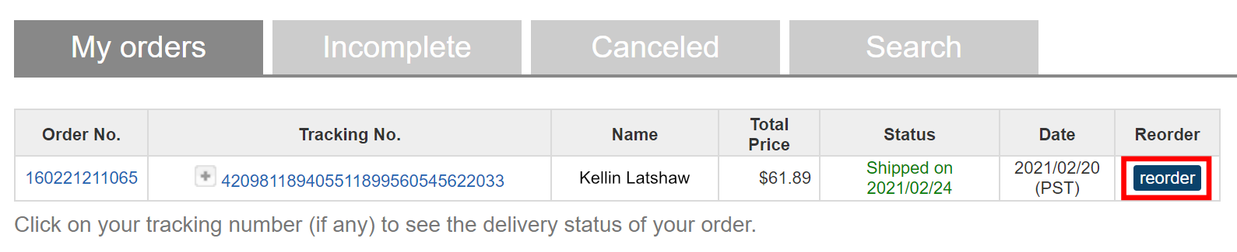

1. Select **Submit**.

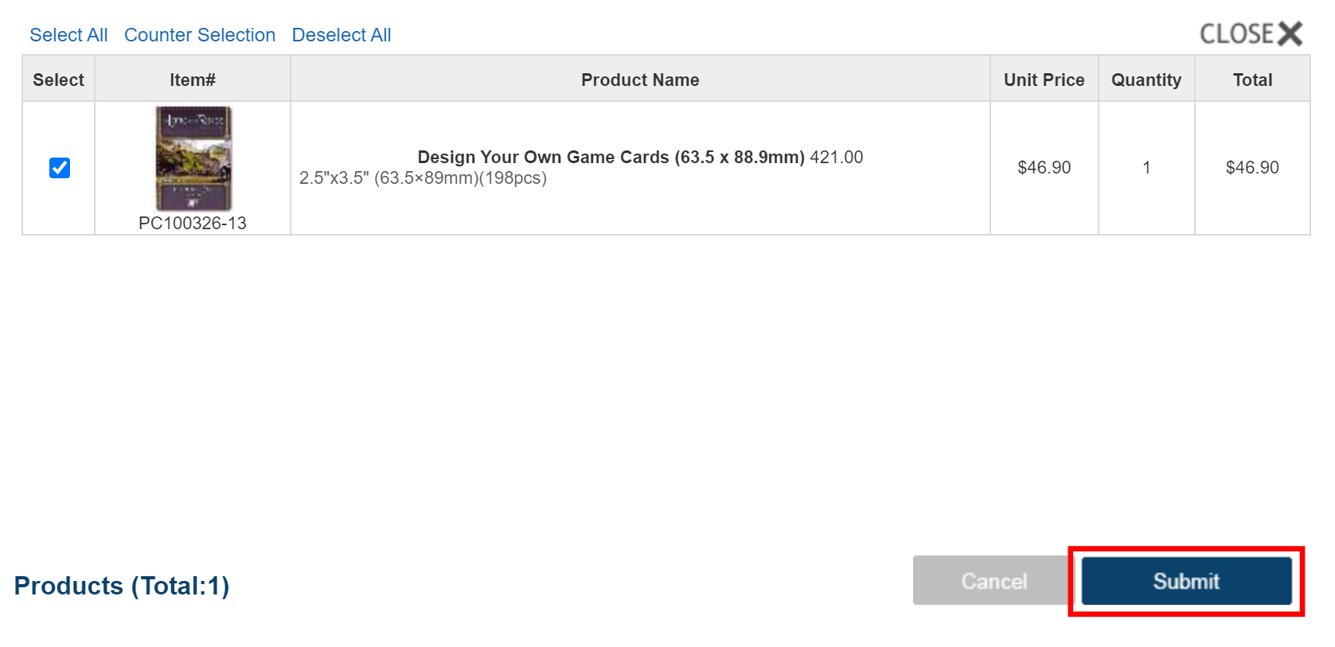

1. Select **OK** in the browser prompt to verify that you want to add your order back into your cart.
2. Follow the steps in Removing the Deck From Your Cart to finish saving your deck as a project.

# Creating a MakePlayingCards Project Link

Once you save your deck as a MakePlayingCards project, you can create a project link to share with others (see Using Links to MakePlayingCards Projects for details). Note that users must be signed into a MPC account to view your project link.

1. Sign in to your MakePlayingCards account (see Signing In for details).
2. Select **Saved projects**.

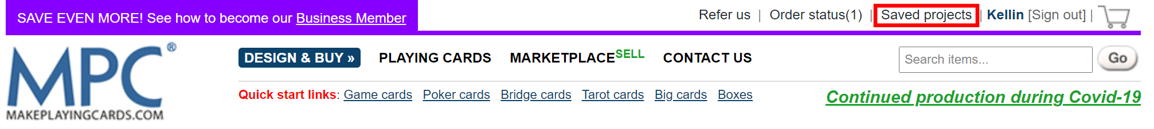

1. Find the deck under **My saved projects** (see Saving Your Deck as a MakePlayingCards Project for details on how to save your deck).
2. Right-click the checkbox to the left of the deck.

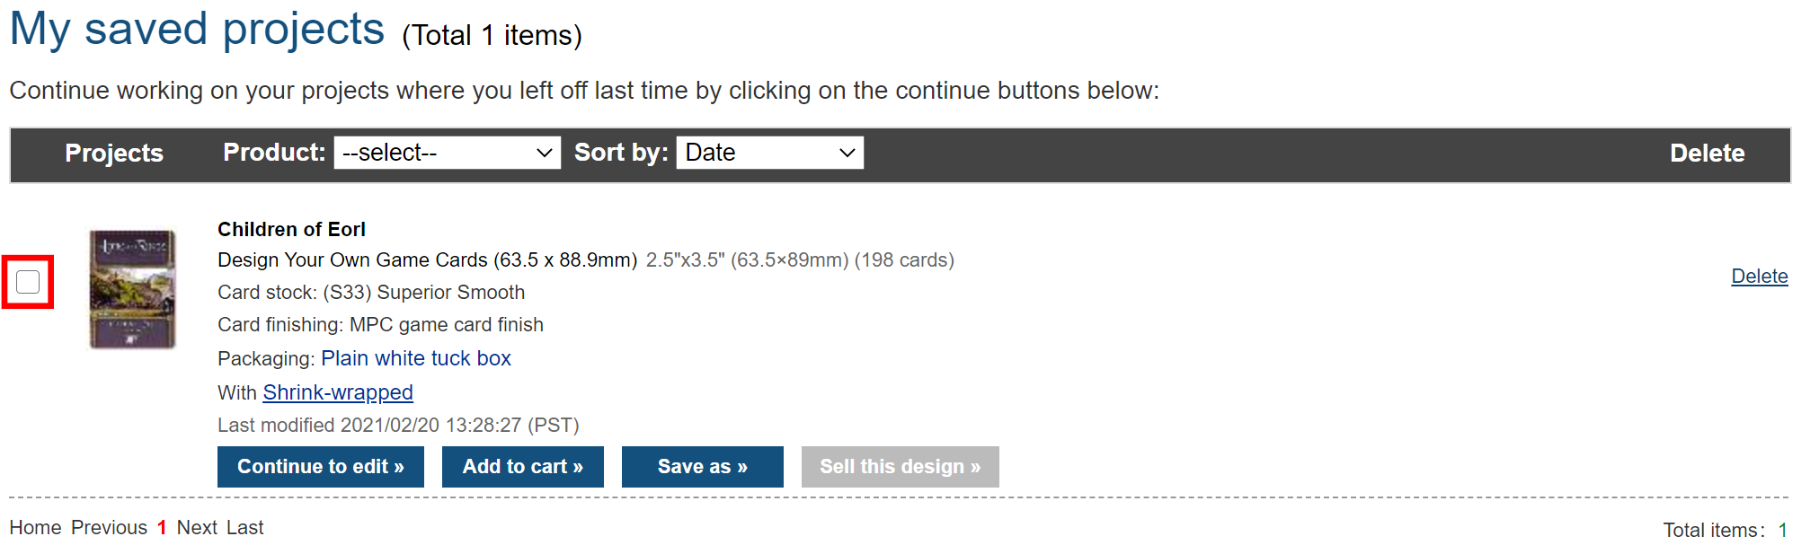

1. Select **Inspect** (on Google Chrome) or **Inspect Element** (on Firefox, Safari, and Microsoft Edge).
   1. You should see the source code of the web page with the line of code for the checkbox highlighted.

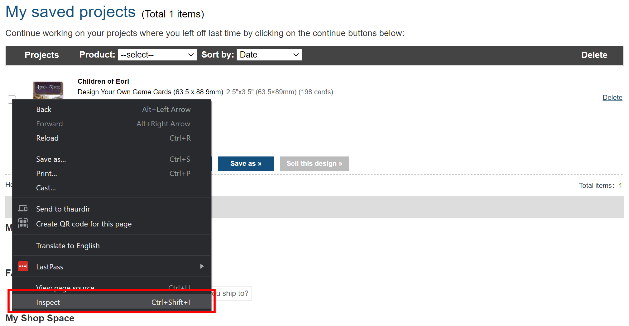

1. Copy the ID of the input element **without** the “chk_” prefix.

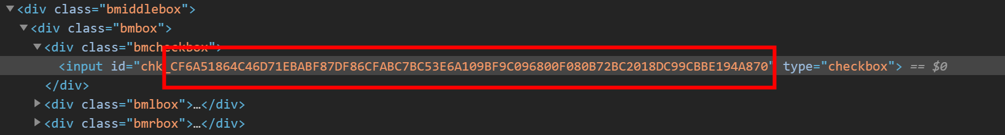

1. Create your URL using the following format:

https://www.makeplayingcards.com/design/dn_temporary_parse.aspx?id=<your long ID>

For example, the project link for the above project is:

<https://www.makeplayingcards.com/products/playingcard/design/dn_playingcards_front_dynamic.aspx?id=CF6A51864C46D71EBABF87DF86CFABC7BC53E6A109BF9C096800F080B72BC2018DC99CBBE194A870>

# What to do if MakePlayingCards Rejects Your Order

If you receive an email from MakePlayingCards that they can’t print your order because of copyright issues, try to answer them with the following:

Hello,

Thanks for your message.

All cards below are NOT copyrighted images. It’s a fan-made extension to The Lord of the Rings Living Card Game (LCG) and it fully complies with “Guidelines For Community Use” released by Fantasy Flight Games/Asmodee North America (see [*https://images-cdn.fantasyflightgames.com/filer_public/fa/b1/fab15a15-94a6-404c-ab86-6a3b0e77a7a0/ip_policy_031419_final_v21.pdf*](https://images-cdn.fantasyflightgames.com/filer_public/fa/b1/fab15a15-94a6-404c-ab86-6a3b0e77a7a0/ip_policy_031419_final_v21.pdf) ). In short, Fantasy Flight Games encourages people to create fan-made content, as long as it’s not for sale and either made for personal use or freely shared with the community.

I’m going to print the cards for personal use only and not for resale.

Thank you!

If your order is still rejected, cancel it and try to place it again (hopefully, it will reach a different MakePlayingCards employee).